TEXTURE, TYPE & COLOUR

Type: cutted slips from solid moulded bricks
Texture: solid unsanded, smooth texture
Colour: yellow ochre with nuances

Slips, corner slips, horizontal slips and stretcher reveal slips: available on this thickness.
Other formats and thicknesses available on request.

TECHNICAL CHARACTERISTICS
The bricks are delivered with the following characteristics, in accordance with the CE mark:
CE mark according to EN 771-1 : 2011 + A1 : 2015

Dimensions L x W (height) x T ca. | 212x64x20 mm
Quantity/m² joint 10-12 mm ca. | 59
Quantity/m² joint 5-6 mm ca.  Quantity/m² joint 4-5 mm ca. | 66  68
Gross mass density | 1900 Kg/m³ (+/- 20%)
Water absorption (24 hours) | < 16%
Initial water absorption (1 minute) | < 4 kg/(m² . min ) IW3
Water vapour permeability | µ = 5/10
Thermal properties (λ10, dry, 90/90) | 0,54 W/mK (tabel 1 EN1745)
Durability (frost / thaw / resistance) | F2 – highly frost-resistant
Active soluble salts | class S2
Fire reaction | class A1

Brick slip specifications according to NBN B 23-004 for Belgium

Surface density classic joints | 30 kg/m² (+/- 20 %)
Surface density thin joints | 35 kg/m² (+/- 20 %)
Size tolerance | Tm (+/-8/4/2)
Size spread | Rm (20/6/4)*
Flatness | class 1

surface characteristics

In a sample of 100 slips, at least 95 slips will be undamaged. Are considered to be damages: every broken slip; slips with a broken corner or edge; visible cracks (< 0,2 mm) or uneven sanding or profiling, as far as these have to be considered as disturbing the visible surface of the slips. The minimum diameter of a damage is 15 mm.

The number of defected slips must not exceed 5%. The following are considered defects; the presence of hard spots which may swell and cause the slip visible surface to flake; cracks with a width ≥ 0.2 mm on the visible surface. Any damage or defects must always be reported before use.

* With the except of burn marks that change the dimensions.

TYPES

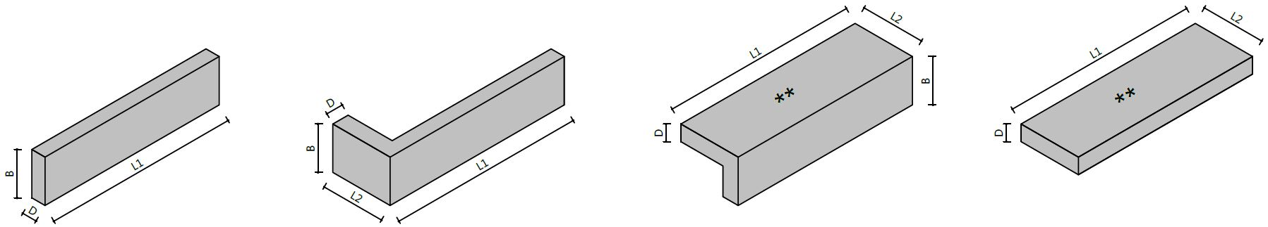

Slips |  | Corner slips |  | Stretcher reveal slips |  | Horizontal slips

** Rough sanded and irregular texture.

dimensions

L1 | Ca. 212 mm
L2 | Ca. 101 mm
B | Ca. 64 mm
D | Ca. 20 mm

RECOMMENDATIONS

In order to create a look that is as homogeneous, the slips must be mixed correctly before processing. That means unstacking them vertically and using at least 5 different packs at the same time. If the slips come from a number of deliveries, sufficient pallets are to be kept back in order to enable the mixing of the different deliveries.
Fresh brickwork should always be protected. The slips must be dry and dust-free during installation.

Dimensions may vary depending on the production. For the most recent version see www.brickz.world. This document is not binding and annuls all previous publications. The manufacturer reserves the right to change the product range and characteristics. The user must always check that he has the most recent descriptive text.

TRANSPORT AND STORAGE
Do not stack the packs.

